

Service tool for amperometric inner body simulation



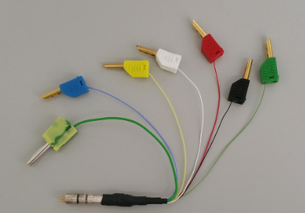

Table of Content

General 2

Required tools 3

Connecting 5

Checking 6

Troubleshooting 7

Service tool for amperometric inner body simulation

General

This tool is used to check all amperometric sensor shaft.

In combination with our advanced and expert service technician seminars we are now able to offer you this new simple tool to facilitate your service activities.
This sensor shaft service tool is portable, handy and easy to use.

This tool can be used for several services on amperometric oxygen sensor-shafts.
This sensor shaft service tool is a simulator for amperometric oxygen inner bodies

For example:
1. Testing for humidity infiltration in the sensor shaft
2. Testing for a short circuit or an interruption in the sensor shaft
3. Performing a temperature simulation
4. As a simulator for various sensor inner bodies
5. Checking the Polarization voltage

Required tools | 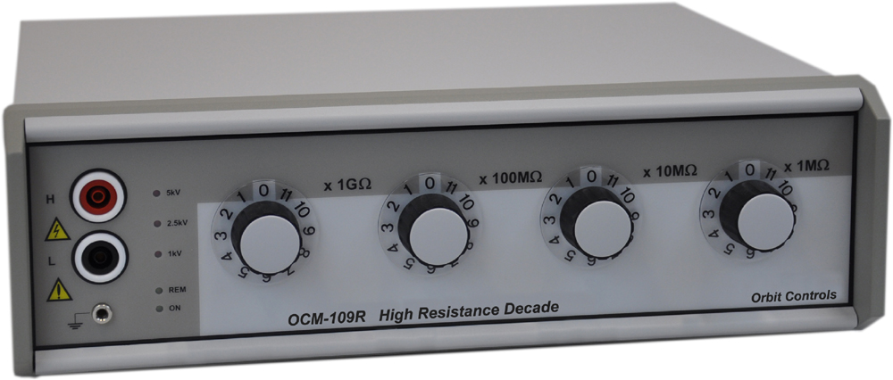  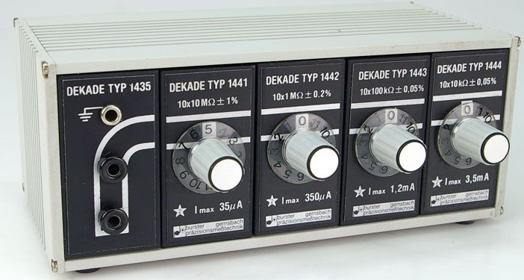  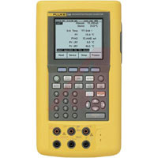  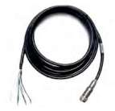  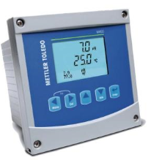 | - 12 GΩ High resistence decade  - Resistance decade  - Multimeter  - VP Cable  - Transmitter
 | Service tool for amperometric sensors
 | Description and function
  Wire | Connector | Simulate
  Temperature/NTC | 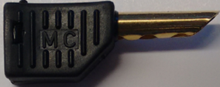 | Temperature
  Temperature/NTC | 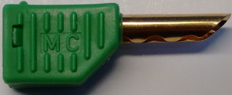 | Temperature
  Cathode | 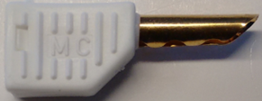 | 100 % AIR
  Anode  Reference | 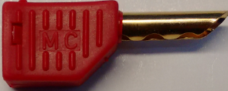  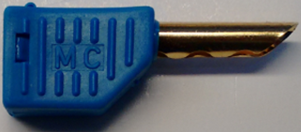 | 100 % AIR
  Guard | 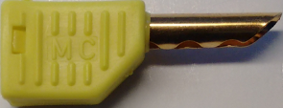
  Shield | 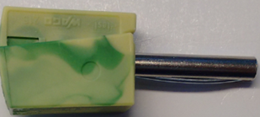

Connection  to simulate  temperature  Connection  to simulate 100 % Air  Connection  to simulate  0 % Air  Connection  to voltmeter to check the  polarization-voltage | 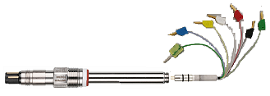 | - Connect the black (temperature) to the 4 mm labor terminal from resistence decade.  - Connect green (temperature) to the 4 mm labor terminal from resistence decade.  - Connect white (cathode) to the 4 mm terminal from high resistance decade.  - Connect red/blue (anode/reference) together to the 4 mm terminal from high resistance decade.  - Connect red/blue (anode/reference) together to the 4 mm terminal from high resistance decade.  - Connect the Service tool for amperometric inner body to the sensor shaft.  - Connect the sensor shaft to the VP cable.  - Connect the VP cable to the transmitter.  - Connect white (cathode) to the multimeter terminal.  - Connect red/blue (anode/reference) together to the multimeter terminal.
  Black 4mm labor connector | 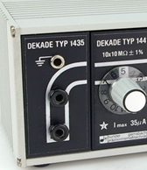
  Green 4mm labor connector
  White 4mm labor connector | 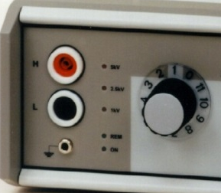
  Red & blue 4mm labor connector
  Red & blue 4mm labor connector
  White 4mm labor connector
  Red & blue 4mm labor connector
Check the 100 % AIR values according to the table  Check the  0 % AIR values  Check the  polarization-voltage  values | 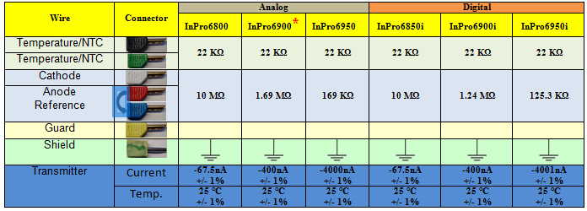  - * M400 with VP-Cable connection  Blue from the VP-Cable wire not used.  Terminal 4 and 6 are internally connected, either terminal can be used to  connect a wire.  - NOTE: Install jumper (supplied) 1 to 3 to 4 when using InPro6900.  - For InPro6900 and InPro6950:  Under configutations, you have to select O2 Low.  - Only for InPro6950: can only be tested with M700 traces module  (Not with M400).  - Important to know, is that the blue and the red wire always should  be connected together (Except for InPro6900).  - To measure the zero point value from sensor shaft, you have to disconnect the cathode (white connector) from the resistance decade.  You should measure a current value from 0 pA +/- (30 pA)  - To check the polarisationvoltage of the sensor shaft, you have to set the multimeter mV DC.  You should measure a voltige value according to the sensor type  (-675 mV or -500mV).
Trouble-  shooting | - Zero current is out of range.  - Air current is too low or „zero“  - Air current is too high.  - Temperature is out of range.  - Polarizationvoltige is out of range. | - Humidity on Transition piece.  - Interruption or short circuit in cable/plug connection.  - Short circuit in service tool for amperometric inner body simulator.  - Interruption in cable/plug connection.  - Setted wrong values on the high resistance decade.  - Short circuit in cable/plug connection or in ISM board.  - Setted wrong values on the high resistance decade.  - Interruption in cable/plug connection.  - Setted wrong values on the high resistance decade.  - Interruption in cable/plug connection.  - Setted wrong values on the transmitter.  - Multimeter wrong setted.  - ISM board defect.

